**COMPUTER SCIENCE DEPARTMENT**

LAB: Database System

**Lab task # 05**

**Last date of Submission: 25th October 2024**

# Submitted To: Mam Kashia Riaz

**Student Name: UBAID-BIN-WARIS**

# Reg. Number: 2212416

# 

**Task 01**

1. **Select * from Customers;**

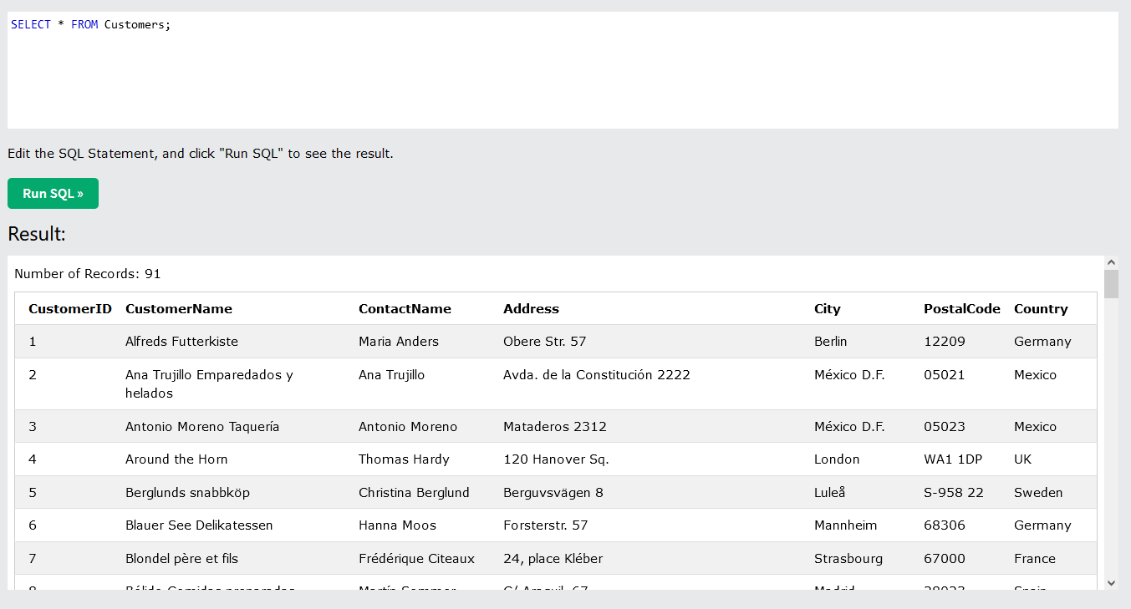

1. **Select Distinct City from Cusromers;**

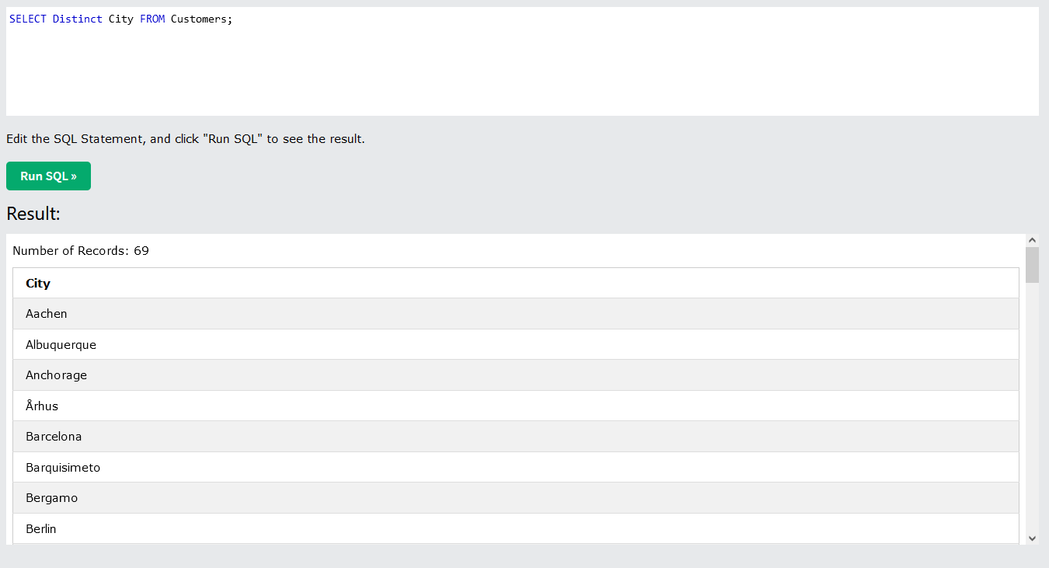

1. **SELECT * FROM Customers where Country = "Mexico";**

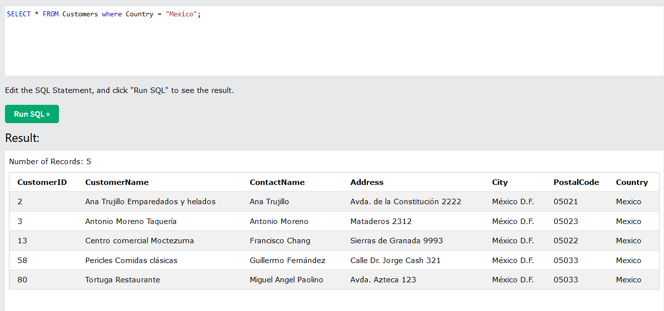

1. **SELECT * FROM Customers where CustomerID = 1 ;**

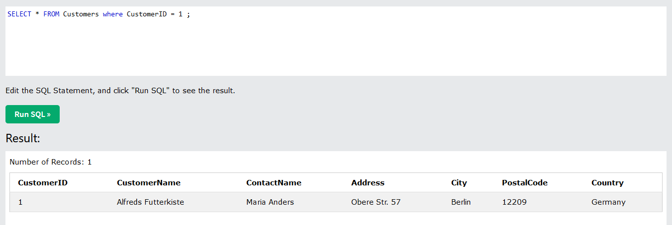

1. **SELECT * FROM Customers where Country = "Germany" OR City = "Berlin";**

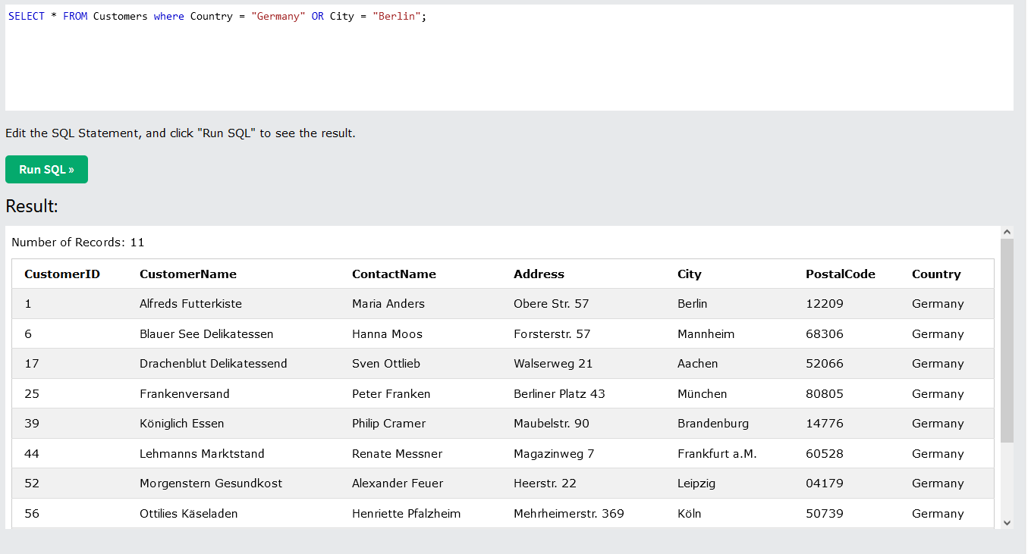

1. **SELECT * FROM Customers Order By PostalCode ASC;**

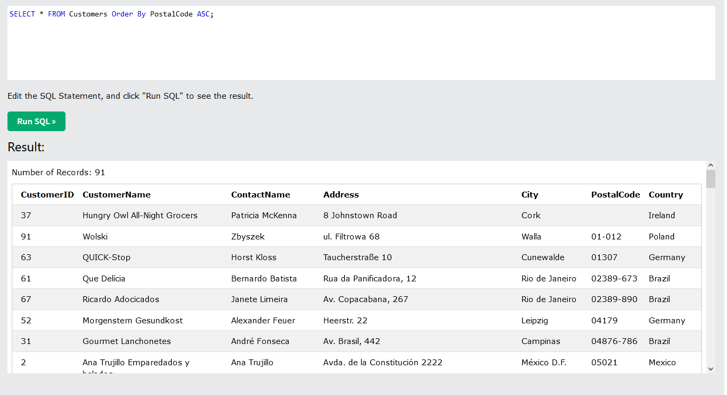

1. **SELECT * FROM Customers where City like 's%' ;**

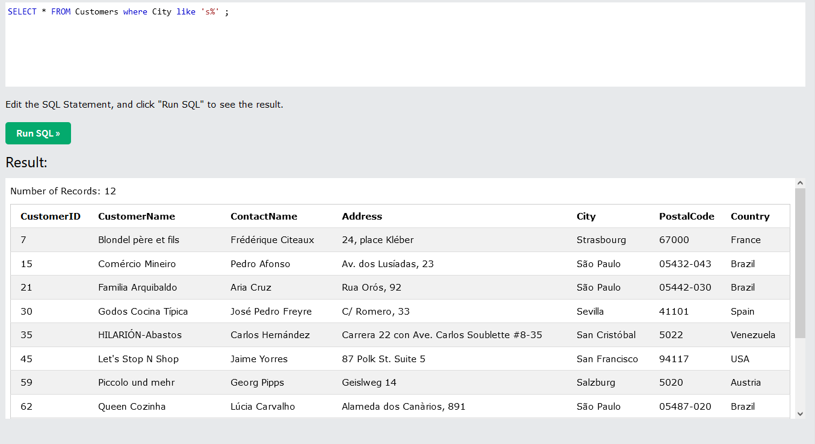

1. **SELECT * FROM Customers where City in ("london","Paris");**

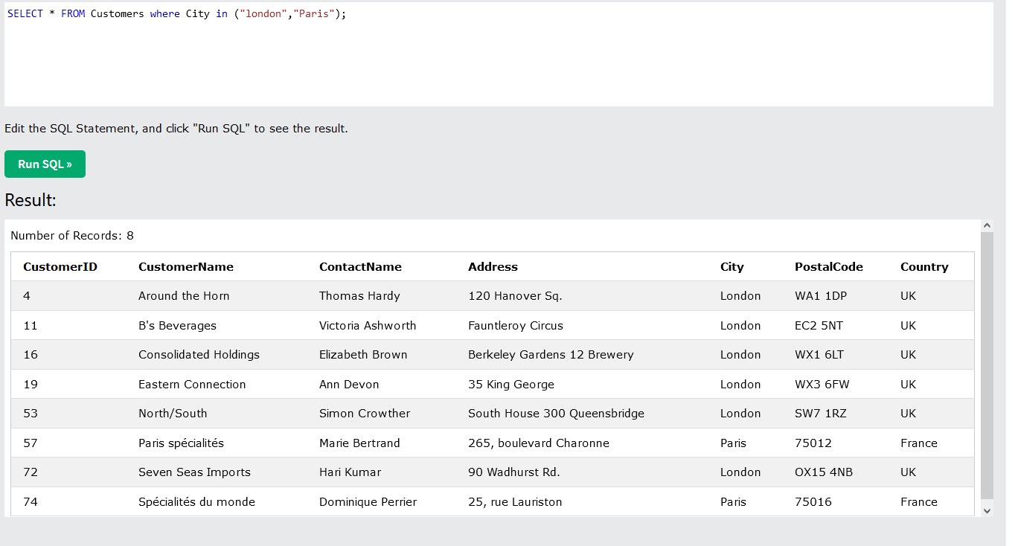

1. **SELECT * FROM Products where price Between 15 AND 20;**

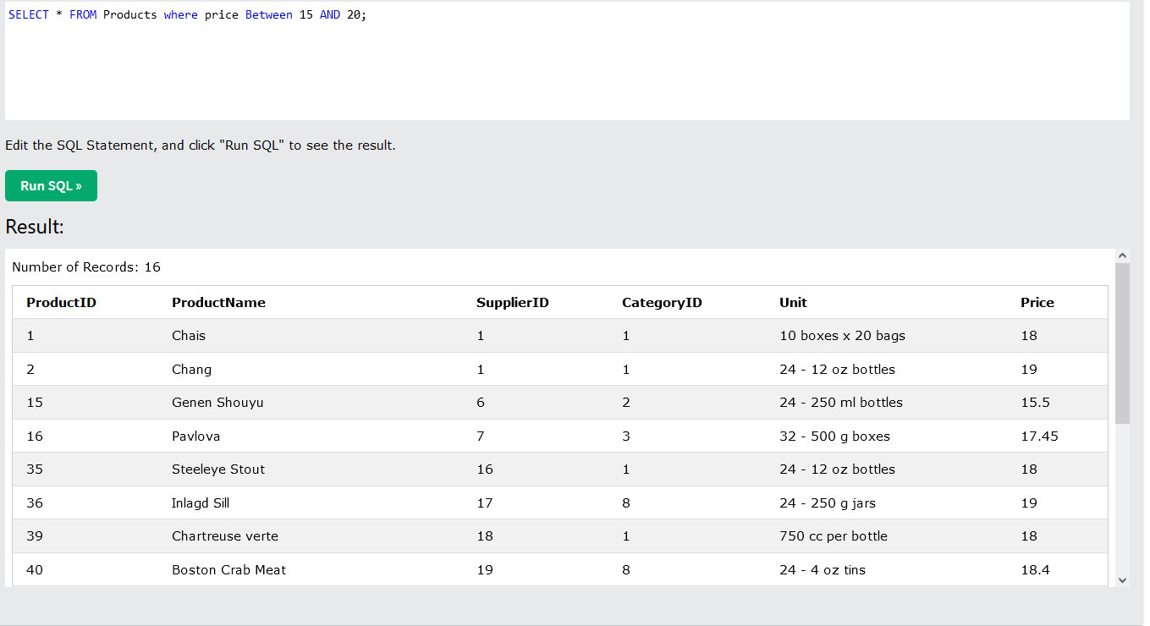

**Task 02**

1. **From the** ItemsOrdered **table, retrieve a list of all items purchased by the customer with** CustomerID = 10449**. Display the** CustomerID**,** Item**, and** Price **for this customer.**

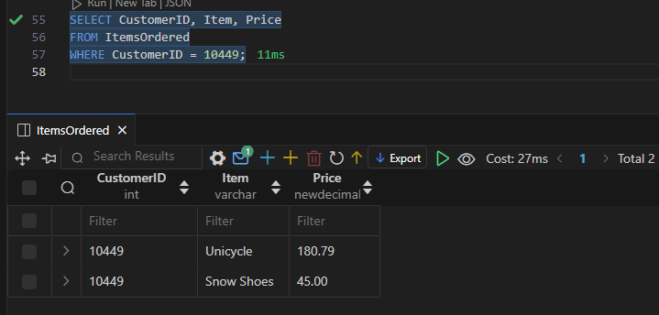

1. **Retrieve all columns from the ItemsOrdered table for any entry where the Item is a "Tent".**

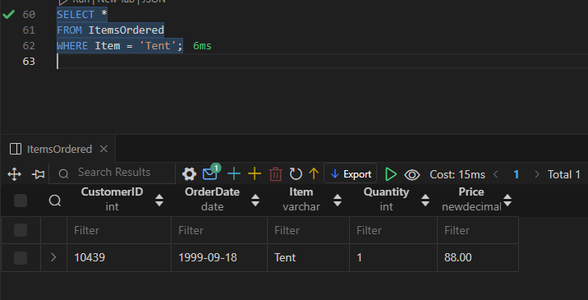

1. **Retrieve the CustomerID, OrderDate, and Item from the ItemsOrdered table for any records where the Item starts with the letter "S".**

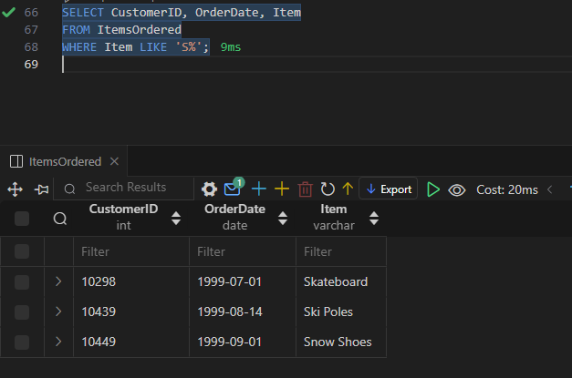

1. **Retrieve a list of all distinct (unique) items in the ItemsOrdered table. Each unique item should appear only once.**

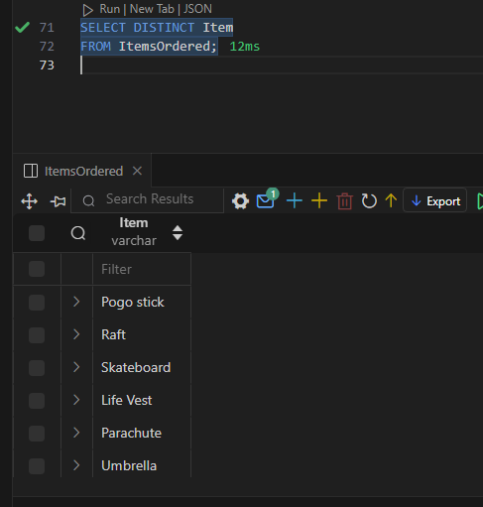

1. **Find the maximum price of any item in the ItemsOrdered table. Only the maximum price should be displayed.**

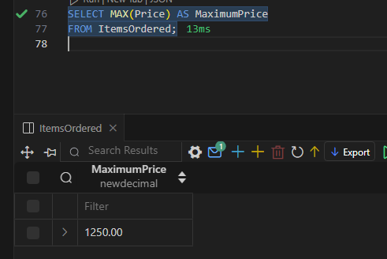

1. **Calculate the average price of all items ordered during the month of December.**

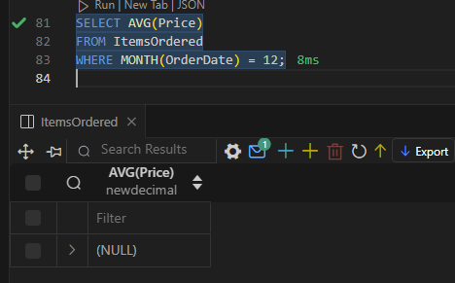

1. **Determine the total number of rows in the ItemsOrdered table.**

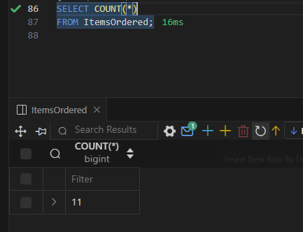

1. **Find the price of the lowest-priced tent from the ItemsOrdered table. Display only the lowest price.**

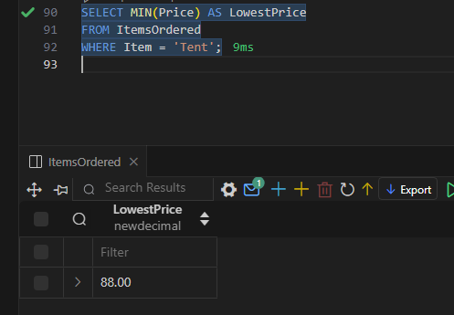

1. **Count how many people are in each unique state in the Customers table. Display the state and the number of people for each.**

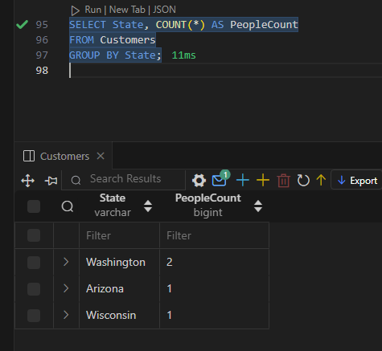

1. **For each specific item in the ItemsOrdered table, find the item name, maximum price, and minimum price.**

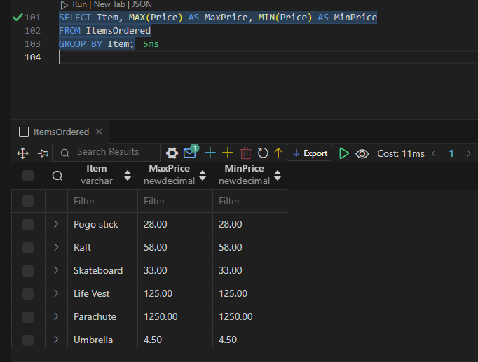

1. **Determine how many orders each customer made. Display the CustomerID, number of orders, and the total sum of their orders.**

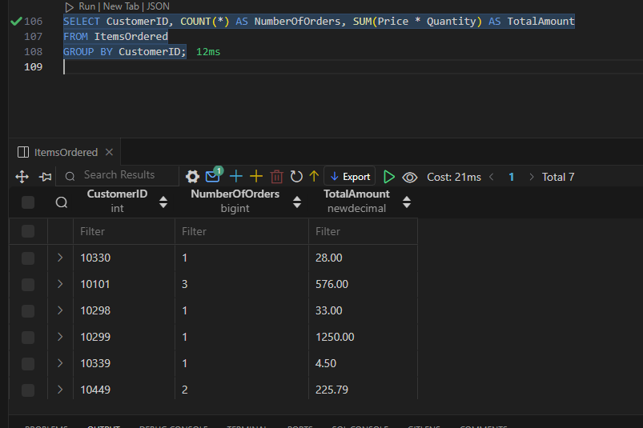

1. **Count how many people are in each unique state from the Customers table where the count is greater than 1. Display the state and the count of people.**

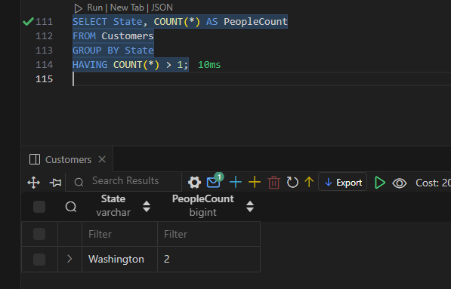

1. **From the ItemsOrdered table, find the item name, maximum price, and minimum price, but only display items where the maximum price is greater than 190.00.**

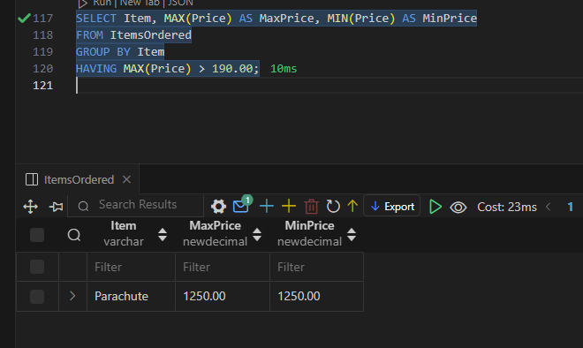

1. **Determine how many orders each customer made where they purchased more than 1 item in total. Display the CustomerID, number of orders, and the total sum of their orders.**

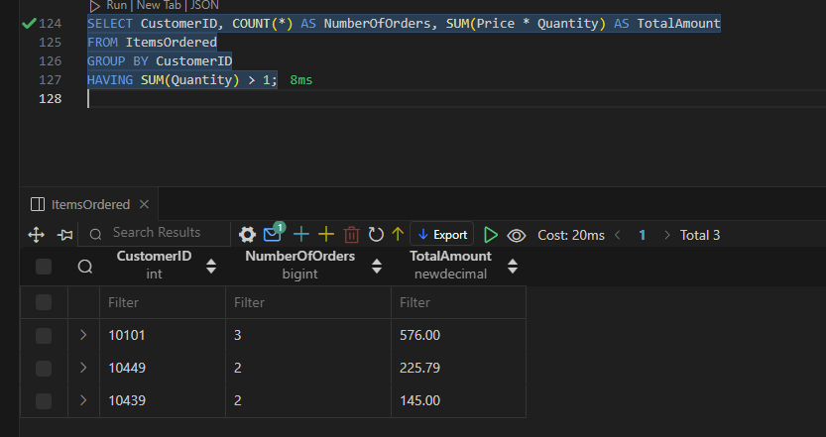

1. **Display the LastName, FirstName, and City of all customers from the Customers table in ascending order of their LastName.**

